Take the case of hour 16 of a simulation:

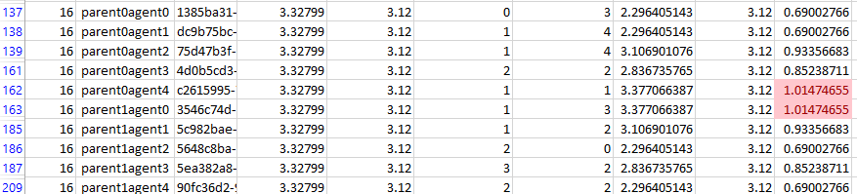

On the face, this could be wrong. If Satisfaction was (allocated demand)/(requested demand), this should not be able to exceed 1. However, what you find is that the average satisfaction is the same as the proportional allocation method.

With hour 15 being enough for all players, the game goes into hour 16 with an equal weight on all canons. We can see in hour 16, the following:

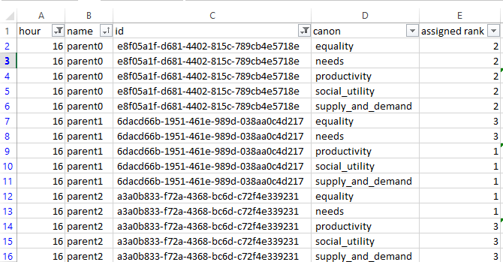

Parent0 is allocated 1/3 of the common pool

Parent1 is allocated 3/10 of the common pool

Parent 2 is allocated 11/30 of the common pool

If we look at individual Agents, we can see that:

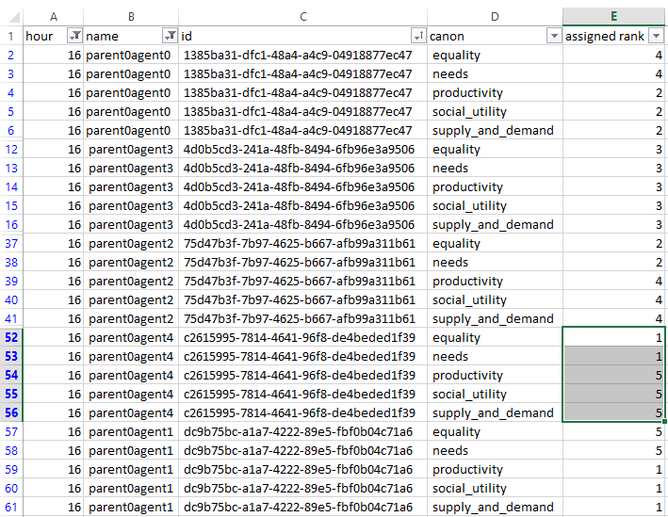

Parent0agent4 is allocated 17/75 of allocation allocated to Parent0. In this case, with the Global total Demand being 46.8, Parent0agent4 is allocated 3.536, which is

Let’s have a look at why that is. During hour 16, we can check the Ranking of the Agents in their respective Community:

And their voting in the ranking in the following round:

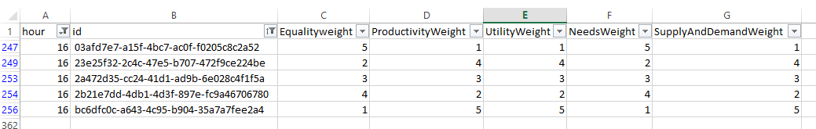

This matches.

We can calculate the combined weight of these: